Abstract so far:
Identifying the technologies that drive innovation often depends on expert judgment or narrow indicators such as citation counts, which can obscure how knowledge actually accumulates and an innovation actually comes into existence.
This research is in developing numerical models of the process of innovation, representing the interconnected network of innovations as a Directed Acyclic Graph (DAGs).
The DAG representation approach is motivated as, if our model is a DAG, we may test methods for identifying critical innovation pathways previously developed on real citation networks, which can also be represented as DAGs.
The proposed argument to generate the innovation DAG is based on a game-theoretic economic model of innovating firms attempting to maximise their profit, where profit is rewarded to a firm for the successful innovation of a new technology.
A technology, t, is defined a set of ideas of length k. $t=\{i_{1},..i_{k}\}$. $k=\left|t\right|$A successful innovation occurs when a given firm
- Has its own idea in t
- knows all ideas in t
- is the only firm that does, therefore can monopolise the technology and innovate
Firms may collaborate to share ideas. Collaboration is modelled such that it imposes both positive and negative externalities. More collaboration facilitates both more learning (leading to more idea exchange and in turn innovation of new technologies) however also more competition (reducing the chance a firm monopolises the profit of a realised innovation).
Each firm pays part of their budget for a higher probability of an idea exchange with another firm. The probability of successful idea exchange between two firms is the product of the probabilities each assigns as a worthwhile investment for this idea exchange.
Each firm simultaneously decides how to spend their individual budget. Then, based on the resulting edge existence probabilities an undirected, unweighted graph is constructed. Each node is a firm, and each edge is a successful idea exchange.
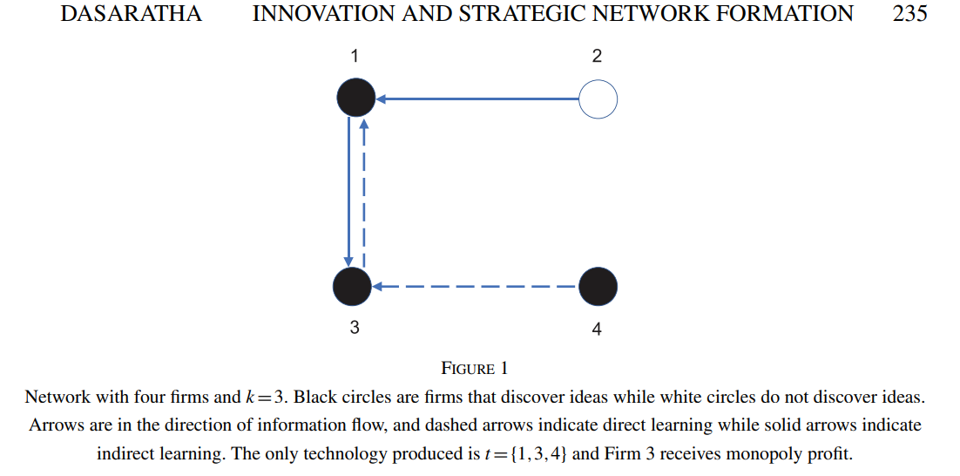
The per game innovation sets and which firms each element belongs too are then realised as a consequence and budget reallocation occurs. In turn, certain firms become richer and others poorer (Need to decide whether bankrupting and firm merging will be modelled, it isn’t in Verspagen (2007)).
The firms then replay this game multiples time without resetting per firm budget or idea edges after each game, in turn introducing a sense of temporal order on the resulting sets of discovered technologies. $G_{j}=\{I_{1A}\left(t(i_{1},i_{2} \right), I_{2A}\left(t\left(i_{5}, i_{31}\right)\right), I_{2B}\left(t\left(i_{2}, i_{32}\right)\right)\}$ (that’s incorrect set notation for this problem)
The gap in the literature (I believe) is in how to take these sets of innovations and turn these into DAGs. But there are options to explore in terms of

